Fencing a Farmer’s Field

John Wensink

MTH122 College Algebra

Colorado State University-Global Campus

Mirela Negoita

July 26, 2020

Fencing a Farmer’s Field

This summer, I would like to build a fence off of my rectangular field that borders a river. I would like to find out the dimensions of the field that occupies the largest area. If I have 1200 feet of fencing material, I should be able to create several diagrams depicting the layout and possible configurations that might maximize the area. Also, I would like to be able to create a function that models the area in terms of one of its sides. After this, I would like to find the point that is the function’s maximum of area. Finally, I would like to calculate the area of the field at the maximum discovered and compare results based on the previous estimate’s diagrams.

**Diagrams**

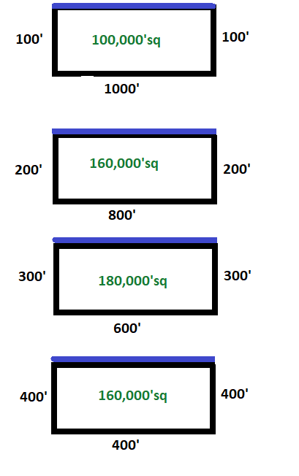

Based on the diagrams I have a high degree of confidence that the fencing layout for a rectangular fence where one side is not needed will bee around the 300’ x 600’ x 300’ point. It sure would be useful if we had an equation to determine exactly what measurements of fence length would maximize the area of the field.

**Find the Function**

A good starting point to find this function would be to create an expression that models the field’s area in terms of a single side. We will call the length of the rectangle x, therefore the width of the rectangle y would have to be 1200-2x. Now if we are wanting to create an expression that describes the area of the rectangle in terms of x, we will need an equation that describes the area of the field we see that a = xy, and we know that y=1200-2x. This gives us a quadratic function when solving for the area a=x(1200-2x), or put another way a(x)=1200x-2x2. In terms of the quadratic formula here the terms a, b, and c are -2, 1200, and 0. The maximum area will occur when x= (-b/2a) (Lamar State College-Orange, n.d.) here -1200/(2*-2), or x=600 feet. As it turns out, our estimation did a perfect job of finding the values that created the maximum area, but this might not always be the case.

**Conclusion**

It is handy to be able to use the quadratic formula to be able to calculate these things in any sort of situation outside of the classroom. Armed with the quadratic formula we have given ourselves the ability to easily calculate the value of the equation based on input values. Examples of real life quadratic equations in action include projectile motion, the motion of our solar system, as well as by car-makers when calculating the braking distance required for a given speed. Yes, quadratic equations are all around us and people who are skilled with their use will enjoy the confidence of knowing how to use this formula in applications both known and unknown.

References

Lamar State College-Orange. (n.d.). Quadratic Word Problems Involving Maxima or Minima. Retrieved July 26, 2020, from <https://www.lsco.edu/learningcenter/Maxima-Minima_Problems.pdf>